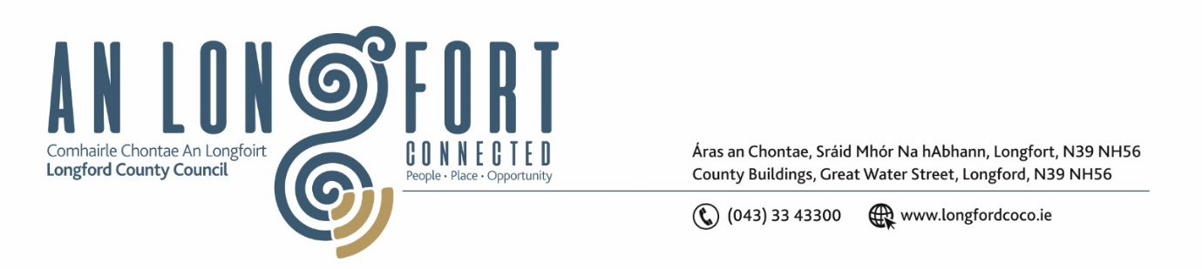

***LONGFORD MUNICIPAL DISTRICT***

***Please note meeting will be held via Microsoft Teams***

**17th November 2021.**

**To: Each Member of Longford Municipal District.**

**Dear Member,**

You are requested to attend the Meeting of Longford Municipal District to be held

**via Microsoft Teams** on **Wednesday 24th November 2021 at 3.30pm** to transact business, as set out on the Agenda hereunder.

**Yours sincerely**,

Ann Marie Mc Keon

_______________

**Ann Marie Mc Keon**

**Meetings Administrator.**

**AGENDA**

Prayer before meeting.

**1.** (i)Confirmation of Minutes of Longford Municipal District Meeting held on

Wednesday 12th October 2021 – copy enclosed.

(ii) Confirmation of Minutes of Longford Municipal District Committee Meeting

held on Wednesday 27th October 2021 – copy enclosed.

(iii) Confirmation of Minutes of Longford Municipal District Meeting held on

Wednesday 27th October 2021 – copy enclosed.

**2.** Matters arising from Minutes.

**3.** Declaration of Interest by Members.

**4.** Management Report -to follow.

**5**. Proposed Projects/Expression of interests - enclosed.

**6.** Item referred from Strategic Infrastructure Strategic Policy Committee Meeting held on the 21st October 2021 –

* Paid Parking Policy for Waivers – enclosed.

**7.** Taking in charge “Brickfields, Abbeycartron, Longford” – enclosed.

**8.** Notices of Motions, submitted by Councillors, as listed hereunder –

**Councillor Uruemu Adejinmi**

1. “I call on Irish Water to provide drinking water for residents and businesses affected by the Boil Water Notice in the Longford MD Area”.
2. “I call on Longford County Council to erect a barrier rail along the Camlin from under the bridge, past the Council Office on Great Water Street, until the Mall”.
3. “I call on Longford County Council to reach out to landlords of RAS properties, and landlords in general, if they wish to sell their properties to Longford County Council”.